School Voting System (voting-app3)

Deployment and Operations Guide

Version 1.0 — November 3, 2026
Prepared from the codebase and the interactive guide (guide/)

Table of Contents
Right-click here and choose “Update Field” to build the table of contents.

1. Environments overview
Environment | Where | Database | Deploy method
--- | --- | --- | ---
Development | Local XAMPP on Windows | MariaDB 10.4.32, DB voting_app | Files edited in place under C:\xampp\htdocs\voting-app3
Production | Render (Docker php:8.3-cli) | Neon PostgreSQL (serverless) | Git push → Render auto-deploy
CI | GitHub Actions | none (read-only checks) | Workflows on push / schedule

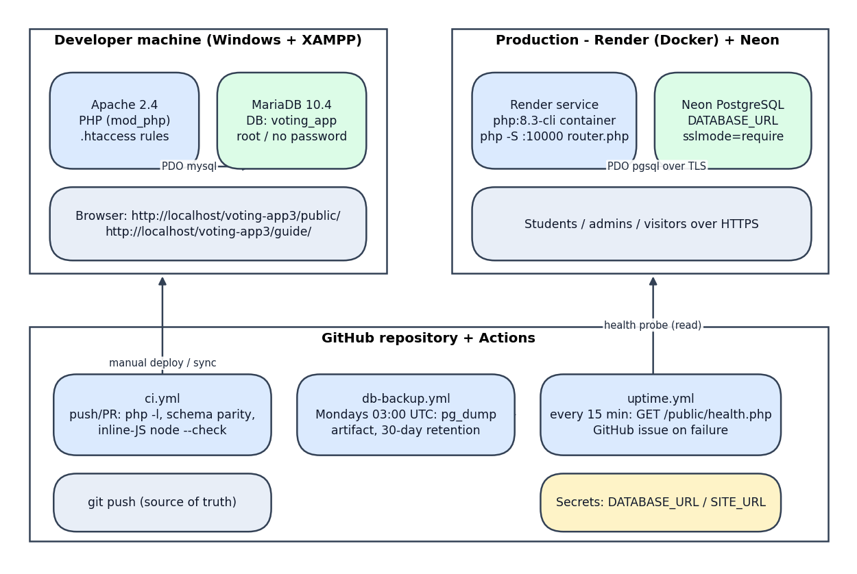
Deployment diagram
Production runs PHP's built-in webserver via php -S 0.0.0.0:10000 config/router.php — config/router.php provides the URL rewriting that Apache .htaccess handles locally.

2. Local deployment (XAMPP)
1. Install XAMPP with PHP 8.2/8.3; place the repo at C:\xampp\htdocs\voting-app3.
2. Start Apache + MySQL from the XAMPP control panel.
3. Create and seed the schema:
mysql -u root voting_app < database\schema.mysql.sql
4. Run the pre-flight verifier (checks PHP version/extensions, DB connectivity, required tables, seeded accounts):
powershell -ExecutionPolicy Bypass -File tests\verify-local-env.ps1
5. Open http://localhost/voting-app3/public/landingpage.php and log in with the seeded demo accounts (student 987654321 / password123; admin admin / admin123).
config/db.php auto-selects the local MariaDB when DATABASE_URL is absent.

3. Production deployment (Render + Neon)

3.1 Provision the database (Neon)
1. Create a Neon project (PostgreSQL 16+); note the connection string.
2. Apply the schema: run database/migration_neon.sql — it is self-sufficient for a fresh install (all tables plus the admin account, demo student, faculties, year levels, and active school year). Use database/schema.sql only when loading the bare DDL without seed data. Record which was used and when.
3. Store the connection string for the next step; enable Neon's point-in-time restore if available on the plan.

3.2 Create the Render service
Setting | Value
--- | ---
Type | Web service, Docker runtime
Image | php:8.3-cli with repo Dockerfile
Start command | php -S 0.0.0.0:10000 config/router.php
Health check path | /public/health.php
Region | Same region as the Neon database (minimizes RTT)

3.3 Environment variables
Variable | Purpose
--- | ---
DATABASE_URL | Full Neon connection string; must include sslmode=require
DB_DRIVER | pgsql (explicit is safest; without DATABASE_URL the app defaults to local MySQL)
DB_HOST / DB_NAME / DB_USER / DB_PASS | Alternative to DATABASE_URL for split credentials
GUIDE_ALLOW_REMOTE | 1 to expose the documentation-guide app in production (off by default)

Secrets are set in the Render dashboard, never committed. Rotate the Neon password by updating it in Neon, then in Render, then redeploy.

3.4 Domain, DNS, and TLS
1. Add the custom domain in Render; point DNS (CNAME) at the Render endpoint.
2. Render issues and renews TLS certificates automatically; HSTS is emitted by the app when it detects HTTPS.
3. Verify: curl https://<domain>/public/health.php returns 200 JSON.

3.5 First-deploy checklist
- ☐ health.php returns {"ok":true,"db":"up"} with HTTP 200
- ☐ Landing page renders; ticker counts non-zero (seed data imported if demo)
- ☐ Admin login works; change the default admin password immediately
- ☐ Student login works; a test vote round-trips; delete test rows afterwards
- ☐ Security headers present (curl -I): CSP, X-Frame-Options, Referrer-Policy, X-Content-Type-Options, HSTS

4. CI/CD workflows
Repository: GitHub Actions under .github/workflows/.
Workflow | File | Trigger | What it does
--- | --- | --- | ---
CI | ci.yml | push, pull request | 1) php -l over all PHP files; 2) php tests/schema_parity.php; 3) extract inline admin JS (tests/extract_admin_js.php) and node --check it
DB backup | db-backup.yml | schedule — Mondays 03:00 UTC | pg_dump of the Neon database from DATABASE_URL secret; uploaded as artifact neon-backup; 30-day retention
Uptime monitor | uptime.yml | schedule — every 15 minutes | Probes <SITE_URL>/public/health.php; on failure opens/updates a GitHub issue titled Site down: health endpoint failing

Required repository secrets/variables:
Name | Type | Used by
--- | --- | ---
DATABASE_URL | Secret | db-backup.yml
SITE_URL | Variable | uptime.yml

4.1 Release procedure
1. Branch → PR → CI green (ci.yml).
2. Run the full smoke suite locally against the updated code (tests/http_smoke.ps1); require 0 FAIL.
3. Merge to main; Render auto-deploys.
4. Post-deploy: check health.php, landing page, and one admin write; watch Render logs for errors.
5. If a defect appears, roll back (section 7).

5. Monitoring and logging
Signal | Source | Where to look
--- | --- | ---
Availability | uptime.yml probes every 15 min | GitHub issue Site down: health endpoint failing; workflow history
Health detail | GET /public/health.php | JSON {"ok":true,"db":"up","time":"..."} with 200; any failure → HTTP 503
Application errors | PHP error_log | Render log stream (Logs tab)
Audit trail | activity_logs table | Admin panel → Logs (all admin writes, with actor and timestamp)
Auth failures | login_attempts table | DB query; feeds rate limiting

Health endpoint contract (used by uptime.yml and any external monitor):
GET /public/health.php200 → {"ok":true,"db":"up","time":"2026-11-03T09:00:00+08:00"}
503 → {"ok":false,"db":"down",...}

5.1 Routine checks (weekly)
- ☐ Uptime issue tracker: no open Site down issue
- ☐ Latest neon-backup artifact exists (last Monday)
- ☐ Render logs: no repeated PHP warnings/errors
- ☐ Spot-check admin results panel against a manual count during live elections

6. Backup and disaster recovery

6.1 Backup inventory
Backup | Cadence | Location | Retention
--- | --- | --- | ---
Automated pg_dump | Weekly (Mon 03:00 UTC) | GitHub Actions artifact neon-backup | 30 days
Manual local backup | On demand | workstation | operator-managed
Neon platform backups | Provider-managed | Neon console (if plan includes PITR) | per plan

6.2 Manual backup (workstation)
tools/backup.ps1 wraps pg_dump for the Neon database:
powershell -ExecutionPolicy Bypass -File tools\backup.ps1 ` -ConnectionString "postgresql://...?sslmode=require" `
-OutDir "C:\backups" -Keep 7
# Optional: -PgDumpPath "C:\path\to\pg_dump.exe" to pin a client version; -ShowCommand to print the raw command (password redacted)
Behavior: writes a timestamped .sql dump, prunes old files beyond -Keep, and redacts the password from any echoed output.

6.3 Restore procedure
# Restore into a fresh PostgreSQL database (destructive to target schema):pg_restore --clean --if-exists -d "<target connection string>" "<backup.dump>"
Verify after restore: schema_parity.php against the restored DB; log in as admin; confirm election and student counts match pre-incident expectations.

6.4 Recovery objectives (qualitative)
- RPO: ≤ 7 days with weekly CI backups alone; ≤ 24 h if manual backups are taken on election days (recommended during live voting weeks).
- RTO: ≤ 1 hour — redeploy from main (minutes) + restore latest dump (minutes).
- During an active election window, take a manual backup immediately before polls open and after polls close.

7. Rollback and recovery
Scenario | Action
--- | ---
Bad deploy (code defect) | Render → rollback to previous deploy; or revert commit on main and push (auto-redeploy)
Schema migration failed midway | Restore latest dump (§6.3) into the database, re-apply the intended migration fixed
Database outage (Neon) | Status page + support; app shows degraded state (pages render with empty data rather than fatal errors); monitor health.php
Compromised credentials | Rotate Neon password + admin passwords; review activity_logs for unauthorized writes; check login_attempts for brute-force patterns
Accidental data deletion | Restore from latest artifact into a scratch DB, extract the lost rows, re-insert

8. Operational costs and subscriptions
Service | Purpose | Cost model (verify current pricing at renewal)
--- | --- | ---
Neon | Production PostgreSQL | Free/usage tier by compute hours + storage
Render | Web service hosting | Per-instance monthly plan
GitHub | Repo + Actions minutes | Free tier (public) or per-seat
Chart.js CDN (jsDelivr) | Charts library | Free (see Document 02 §7 SRI pinning)

9. Maintenance calendar
When | Task | Reference
--- | --- | ---
Every 15 min (auto) | Uptime probe | uptime.yml
Weekly (auto, Mon 03:00 UTC) | pg_dump backup artifact | db-backup.yml
Weekly | §5.1 routine checks | this doc
Monthly | Review and prune old vote_drafts, expired login_attempts, stale activity_logs (admin Settings → maintenance actions) | Document 10 §7
June 1 (Manila) | School-year cutover: run Next School Year in admin Settings; verify dashboards, verify one-active school-year rule | Document 10 §9; Document 04 §4
Per election | Manual backup before open + after close; archive election after finalization | this doc §6.4; Document 10 §8
Quarterly | Dependency/SRI review (Chart.js, SheetJS pins); PHP version review | Document 11 §2

